**. DS18B20 Sensor**

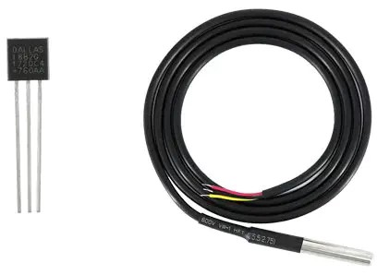

**Fig.7: ds18b20**

**Working Principle:**

The DS18B20 is a digital thermometer that operates based on the principles of the One-Wire protocol. It uses a 1-Wire communication bus, which means it requires only one data line for communication with the microcontroller. This simplifies the wiring and makes it easy to interface with microcontrollers like the Arduino.

**Key Features:**

* High Precision: The DS18B20 offers high-precision temperature measurements with a resolution of up to 12 bits, allowing for temperature readings as fine as 0.0625°C.
* Wide Temperature Range: It is designed to operate over an extended temperature range, typically from -55°C to +125°C, making it suitable for both extreme cold and hot environments.
* Multiple Sensors on a Single Bus: The One-Wire protocol allows you to connect multiple DS18B20 sensors to a single microcontroller, each with a unique 64-bit ROM code, enabling multi-point temperature monitoring.
* Parasite Power Mode: The DS18B20 can operate in a "parasite power" mode, where it derives power from the data line, eliminating the need for a separate power source connection.
* Waterproof Versions: Some DS18B20 sensors come in waterproof packages, making them ideal for applications in wet or outdoor environments.
* Low Power Consumption: This sensor has low power requirements, making it suitable for battery-powered applications.

**Communication:**

The DS18B20 communicates with a microcontroller through the One-Wire protocol, where it sends digital temperature data to the microcontroller. The microcontroller can request a temperature reading from the sensor, and the DS18B20 will respond with the temperature data. The communication is digital, and the sensor uses a unique 64-bit ROM code to identify itself on the bus.

**Applications:**

* The DS18B20 temperature sensor finds a wide range of applications, including but not limited to:
* Environmental Monitoring: Used in weather stations, greenhouses, and outdoor temperature monitoring systems.
* Industrial Automation: Integrated into industrial control systems for temperature monitoring and control.
* HVAC Systems: Employed in heating, ventilation, and air conditioning systems for temperature regulation.
* Consumer Electronics: Found in appliances like thermostats, coffee makers, and refrigerators.
* Scientific Research: Used in scientific experiments, laboratories, and research projects for accurate temperature measurements.

**Interfacing:**

The DS18B20 can be easily interfaced with popular microcontroller platforms like Arduino and Raspberry Pi using the One-Wire library or similar libraries. You need to connect the sensor's data pin to a digital input/output pin on the microcontroller and provide it with the necessary power supply.

**Accuracy and Calibration:**

The DS18B20 provides accurate temperature measurements; however, it's essential to calibrate the sensor for the most precise results in specific applications. Calibration involves comparing the sensor's readings to a known, accurate temperature source and adjusting the readings accordingly.